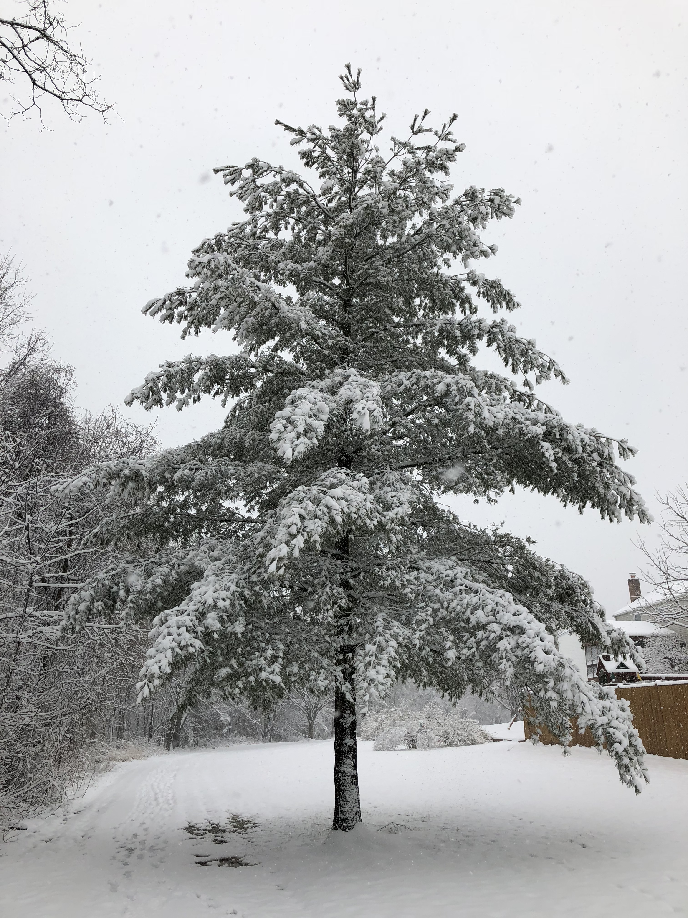  December 2020 |  | Eastern White Pine  (Pinus strobus)  An extremely popular evergreen conifer tree. The term “evergreen” means that the trees retain their needles. They are distributed all throughout eastern North America. They can grow to be 80 feet tall and 40 feet wide, quickly, due to their rapid growth rate. Four inch long, soft, thin, bluish-green needles occur in bundles of five, helping to distinguish eastern white pine from other pines. The slender cones are about 6” in length and lack prickles on the tips of their scales, also a distinguishing characteristic.

Sunday | Monday | Tuesday | Wednesday | Thursday | Friday | Saturday
 |  | 1 | 2 | 3 | 4 | 5
6 | 7 | 8 | 9 | 10 | 11 | 12
 | Pearl Harbor Remembrance Day |  |  |  | First Day of Hanukkah
13 | 14 | 15 | 16 | 17 | 18 | 19
20 | 21 | 22 | 23 | 24 | 25 | 26
 | First Day of Winter |  |  | Christmas Eve | Christmas Day
27 | 28 | 29 | 30 | 31

