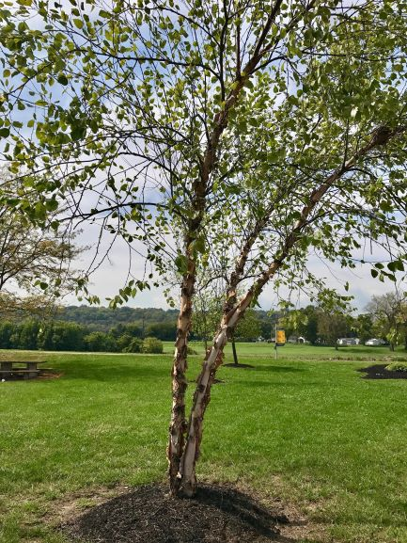  July 2020 |  | Dura Heat  River Birch  (Betula nigra 'BNMTF'  DURA-HEAT)  A native, medium to large sized tree. As a single trunk tree, it can reach heights of 70 feet. Typically, in urban settings, it is found as a multi-trunked and grows to a mature height of 50ft. The leaves of River Birch are recognized by their triangular shape due to their wide base. The bark is by far the most appealing and easily identifiable characteristic of this beautiful tree. Native trees have dark gray to black outer bark that is extremely flaky, exposing hints of an orange and cream inner bark.

Sunday | Monday | Tuesday | Wednesday | Thursday | Friday | Saturday
 |  |  | 1 | 2 | 3 | 4
 |  |  | Canada Day |  |  | Independence Day
5 | 6 | 7 | 8 | 9 | 10 | 11
12 | 13 | 14 | 15 | 16 | 17 | 18
19 | 20 | 21 | 22 | 23 | 24 | 25
26 | 27 | 28 | 29 | 30 | 31

