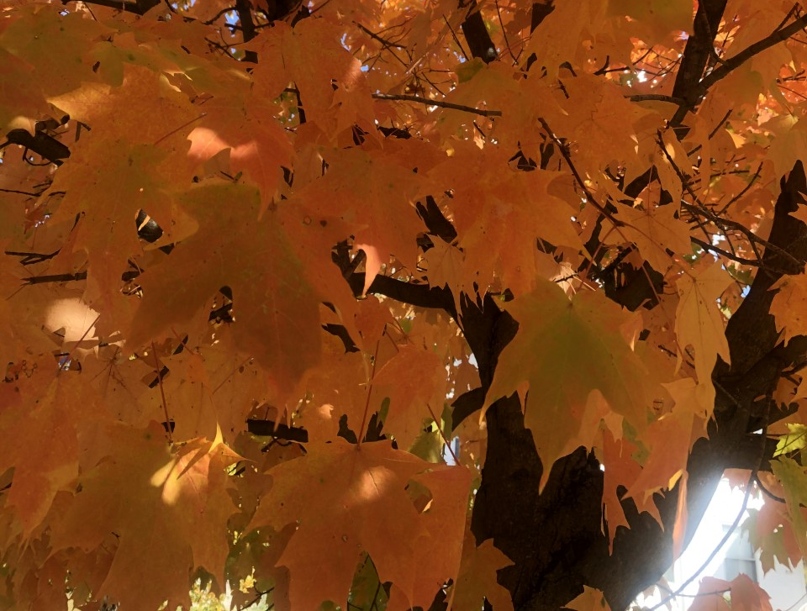  November 2020 |  | Sugar Maple  (Acer saccharum)  A beautiful, native tree you can find all over forests and meadows in Ohio. It possesses spectacular, noteworthy fall color. Sugar Maples are long lived and slow growing. They produce strong, hard, dense wood that has a multitude of uses, including: floors, furniture, veneer, musical instruments, and railroad ties. The most notable trait of this fabulous tree is the amount and quality of maple sap it produces, used to create maple syrup.

Sunday | Monday | Tuesday | Wednesday | Thursday | Friday | Saturday
1 | 2 | 3 | 4 | 5 | 6 | 7
All Saints Day  Daylight Savings Time Ends |  | Election Day
8 | 9 | 10 | 11 | 12 | 13 | 14
Veterans Day
Remembrance Day (Canada)
15 | 16 | 17 | 18 | 19 | 20 | 21
22 | 23 | 24 | 25 | 26 | 27 | 28
 |  |  |  | Thanksgiving Day
29 | 30
First Sunday of Advent

