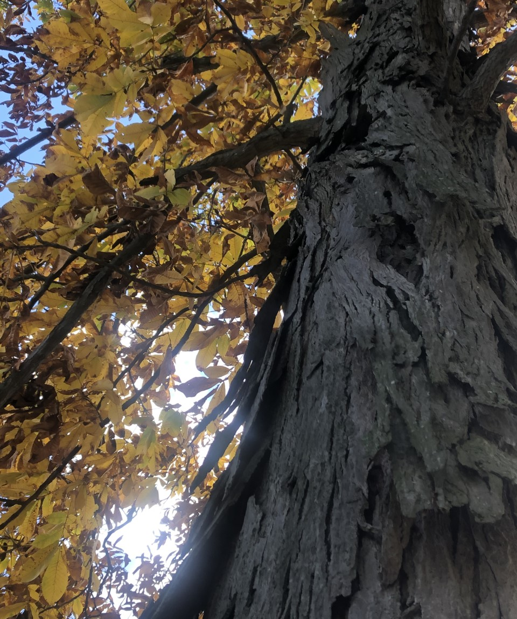  October 2020 |  | Shagbark Hickory  (Carya ovata)  The most popular and well known Hickory species. At maturity, it is easily distinguished from other hickories by its shaggy bark. As a member of the walnut family, it produces edible nuts. Leaves are alternate, pinnately compound with 5 to 7 leaflets which turn golden brown in fall. Hickories make a good addition to a landscape as they are virtually disease and pest free, minimizing maintenance. They have superior drought tolerance and can handle shade when young.

Sunday | Monday | Tuesday | Wednesday | Thursday | Friday | Saturday
 |  |  |  | 1 | 2 | 3
4 | 5 | 6 | 7 | 8 | 9 | 10
11 | 12 | 13 | 14 | 15 | 16 | 17
Columbus Day
Thanksgiving Day (Canada)
18 | 19 | 20 | 21 | 22 | 23 | 24
25 | 26 | 27 | 28 | 29 | 30 | 31
 |  |  |  |  |  | Halloween

