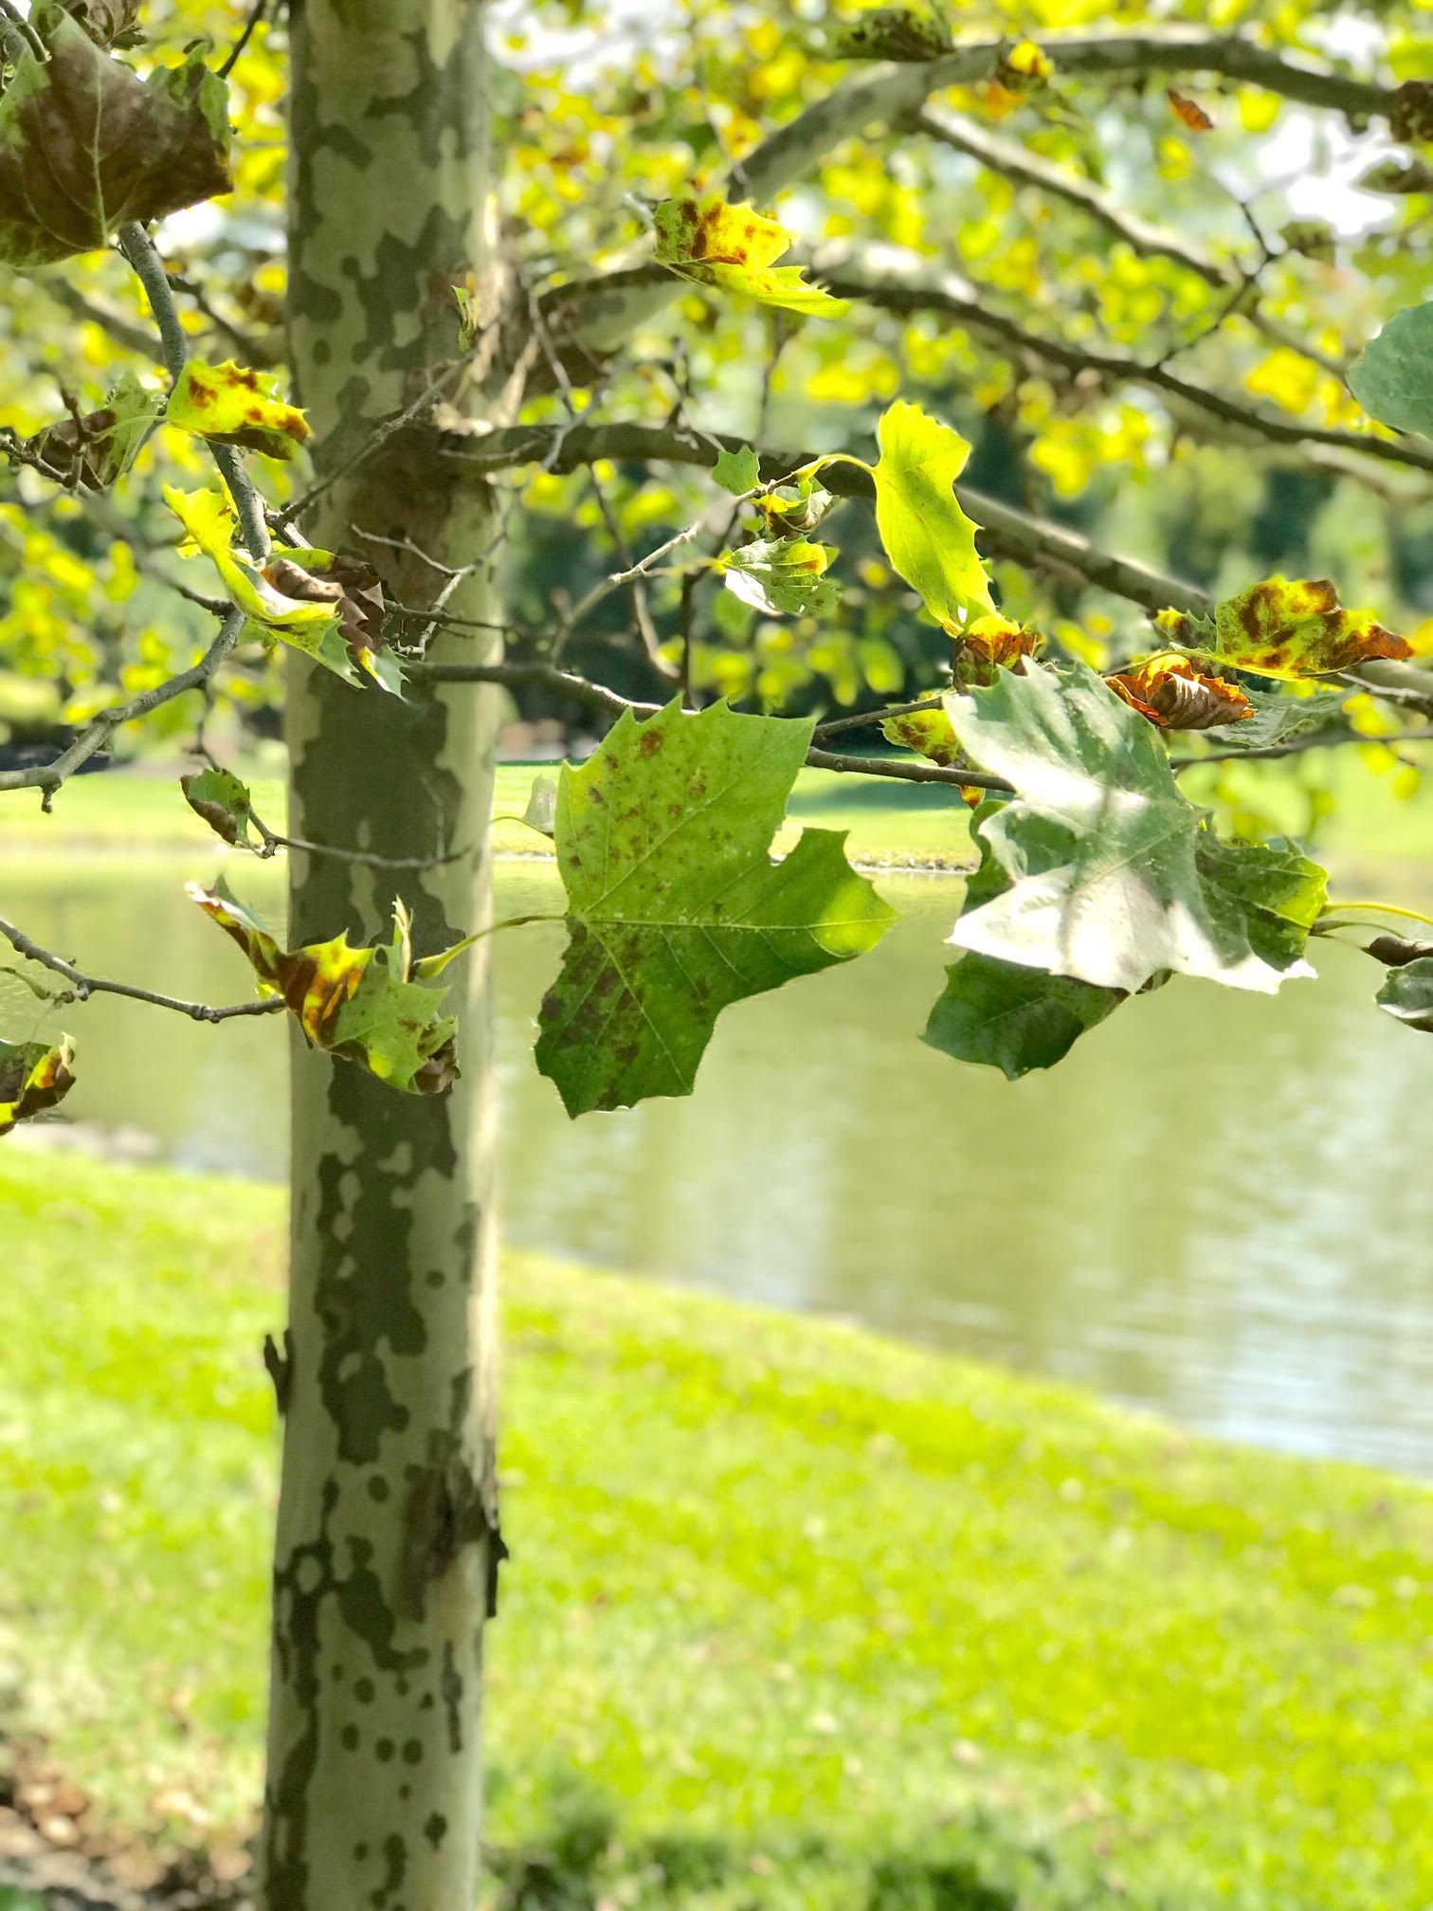  September 2020 |  | American Sycamore  (Platanus occidentalis)  American Sycamore is a large, native, mystical tree that can easily reach heights of 80 feet tall. The bark of this tree is its most alluring quality. Gray-brown bark peels off in large sections around the middle of summer, exposing smooth, white bark. As it matures, a mosaic of white, gray, green and brown, paint this tree. The leaves are green, and fuzzy with 3-5 lobes of varying sizes and indentations emerging during the spring.  )

Sunday | Monday | Tuesday | Wednesday | Thursday | Friday | Saturday
 |  | 1 | 2 | 3 | 4 | 5
6 | 7 | 8 | 9 | 10 | 11 | 12
 | Labor Day
13 | 14 | 15 | 16 | 17 | 18 | 19
 |  |  |  |  |  | Rosh Hashanah
20 | 21 | 22 | 23 | 24 | 25 | 26
National Forest Week begins (Canada) |  | First Day of Autumn
27 | 28 | 29 | 30
 | Yom Kippur

