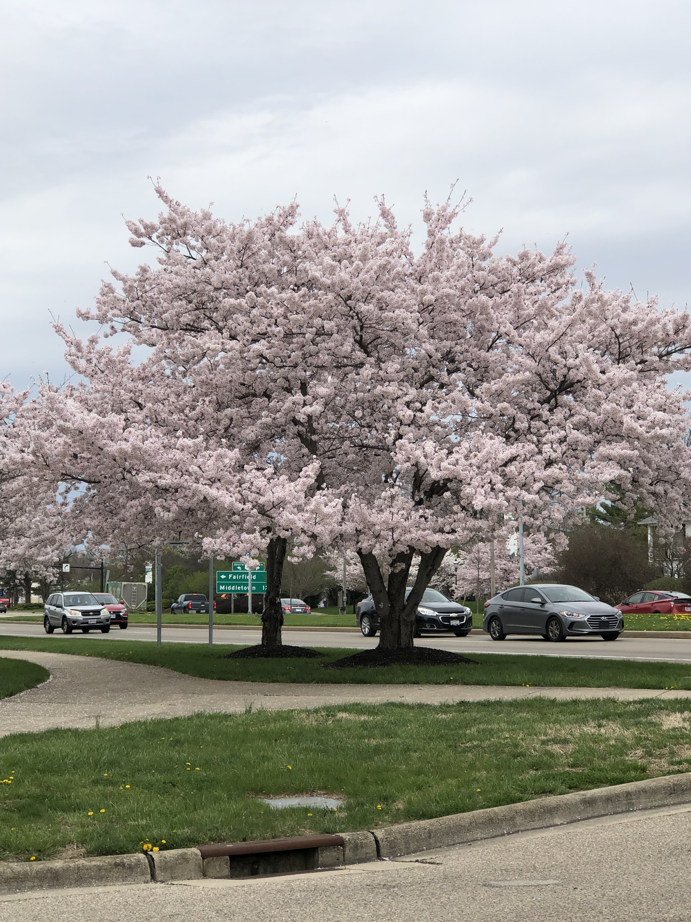  April 2020 |  | Yoshino Cherry  (Prunus x yedoensis)  A graceful, ornamental flowering tree that typically grows 30-40’ tall. Fragrant white-pink flowers in 3 to 6-flowered clusters appear before or during the emergence of the foliage in an abundant and spectacular early spring bloom. Flowers are followed by small black cherries which are bitter to humans but loved by birds. Dark green leaves are elliptic to oval. Fall foliage features yellow with bronze tints in fall. This hybrid cherry comes from Japan and is one of the predominant cherry trees planted in Washington D.C

Sunday | Monday | Tuesday | Wednesday | Thursday | Friday | Saturday
 |  |  | 1 | 2 | 3 | 4
 |  |  | April Fool’s Day
5 | 6 | 7 | 8 | 9 | 10 | 11
Palm Sunday |  |  | First Day of Passover |  | Good Friday
12 | 13 | 14 | 15 | 16 | 17 | 18
Eater Sunday |  |  |  | Last Day of Passover
19 | 20 | 21 | 22 | 23 | 24 | 25
 |  |  | Earth Day |  | National Arbor Day
26 | 27 | 28 | 29 | 30

