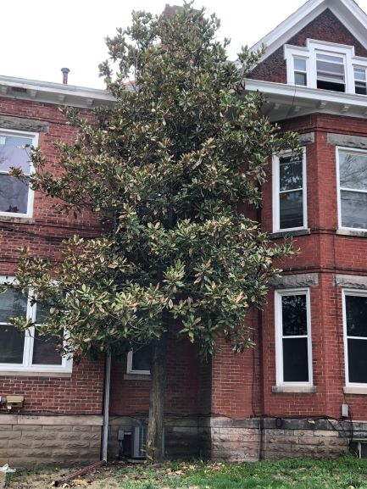  June 2020 |  | Southern Magnolia  (Magnolia grandiflora)  The most iconic and well-known species of Magnolia. It possess large, creamy white and very fragrant flowers that appear in late spring and early summer. Leaves are shiny green and reddish underneath. This tree is an evergreen, meaning it will keep most of its leaves year-round. It is the hardest and heaviest of the magnolia species, commonly harvested and promoted as a good storm resistant urban tree. This tree reaches heights between 60 – 80 feet with a 40 foot spread at maturity.

Sunday | Monday | Tuesday | Wednesday | Thursday | Friday | Saturday
 | 1 | 2 | 3 | 4 | 5 | 6
7 | 8 | 9 | 10 | 11 | 12 | 13
14 | 15 | 16 | 17 | 18 | 19 | 20
Flag Day |  |  |  |  |  | First Day of Summer
21 | 22 | 23 | 24 | 25 | 26 | 27
Father’s Day
28 | 29 | 30

