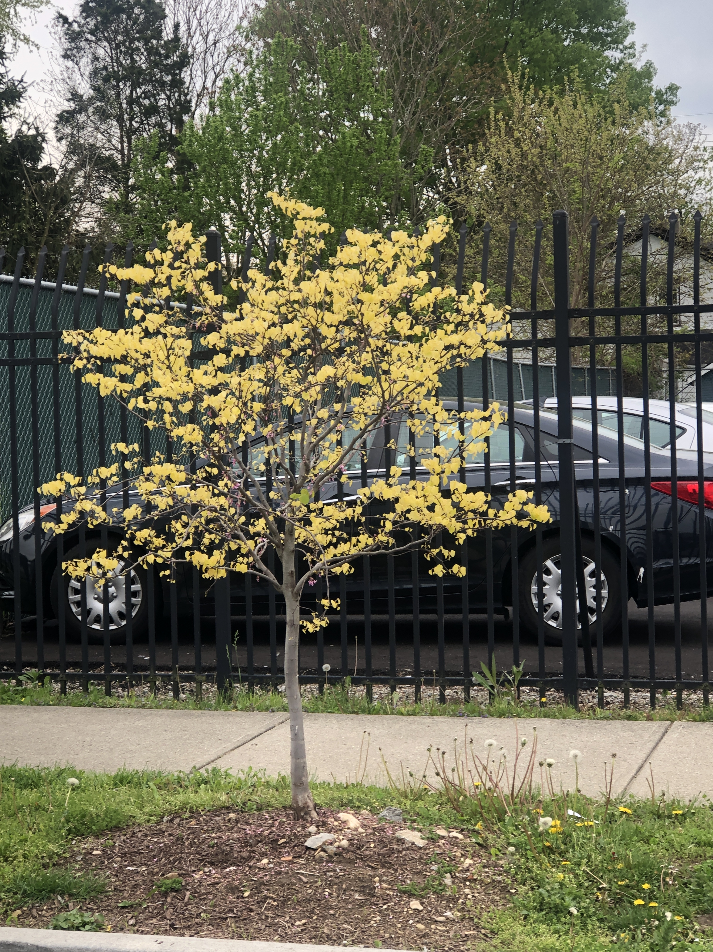  May 2020 |  | Rising Sun Eastern Redbud  (Cercis Canadensis 'JN2')  A unique, small, landscape tree that grows to reach heights of up to 8 – 12 feet and 8 feet wide. Abundant, beautiful, fuchsia pink flowers appear early spring before foliage. Heart-shaped deep apricot leaves emerge and display shades of orange, gold and yellow with all colors present at once! Foliage turns a shade of lime green in the summer heat. This hardy tree is resistant to heat, drought, leaf burn, poor soil, and pollution.

Sunday | Monday | Tuesday | Wednesday | Thursday | Friday | Saturday
 |  |  |  |  | 1 | 2
3 | 4 | 5 | 6 | 7 | 8 | 9
 |  | Cinco de Mayo
10 | 11 | 12 | 13 | 14 | 15 | 16
Mother’s Day |  |  |  |  |  | Armed Forces Day
17 | 18 | 19 | 20 | 21 | 22 | 23
 | Victoria Day (Canada)
24 | 25 | 26 | 27 | 28 | 29 | 30
 | Memorial Day
31

