The City of Hamilton Urban Forestry Marketing Plan

Social Media Output – Monthly Posts
- Instagram
- Twitter
- Facebook
- LinkedIn

Objective
To provide educational information about the benefits of urban forestry, about Hamilton’s urban forest, updates on current projects/educational seminars/events around the city

Post Ideas:
- About popular trees around Hamilton/use data from tree benefits calculator to explain their benefits
- The history of certain trees around Hamilton if available
- Seasonal Seminars
- About Arbor Day/what we do to celebrate it
- General resources for the public:
  - Right tree in the right place/ why we plant trees under power lines
  - Local Nurseries
  - How to properly prune a tree/ Topping is BAD/ Who they should contact to properly prune their trees
  - Basic tree care
- Advertise Ohio Tree ID Instagram
- Advertise the Remarkable Tree Calendar (see objective: in Whitney’s Folder)
- About Hamilton’s Tree Finder App/ Southwest Ohio Plant Selector App (Where to access them)
- About common tree/plant diseases that can be found around the City (therefore what to avoid planting)

April 2020

About Arbor Day

Arbor Day is a holiday that recognizes the importance of trees and encourages people to plant and protect them. Arbor Day originated in Nebraska during the 1800’s all thanks to J. Sterling Morton, his wife Caroline Joy French, and their love for trees. When arriving in the newly formed Nebraska territory in 1854, Morton aspired to encourage tree planting to improve the environment and beautify the landscape to attract people to the area. His idea to assign a day in April dedicated for planting and calling attention to trees became the first Arbor Day, when it is said that Nebraskans planted one million trees. Today, Arbor Day is recognized and celebrated in some way worldwide. The typical date it is observed is on the last day of Friday in April. But it varies for different regions depending on the climate and suitable planting season. Here at the City of Hamilton, we typically celebrate Arbor Day at a local school. Last year, we celebrated at St. Joseph where the children participated in Arbor Day activities to teach them about the importance of trees. The children also partook in helping to plant an Eastern Redbud (Cercis Canadensis) in the court yard at their school.
“Arbor Day is not like other holidays. Each of those reposes on the past, while Arbor Day proposes for the future.”
- J. Sterling Morton
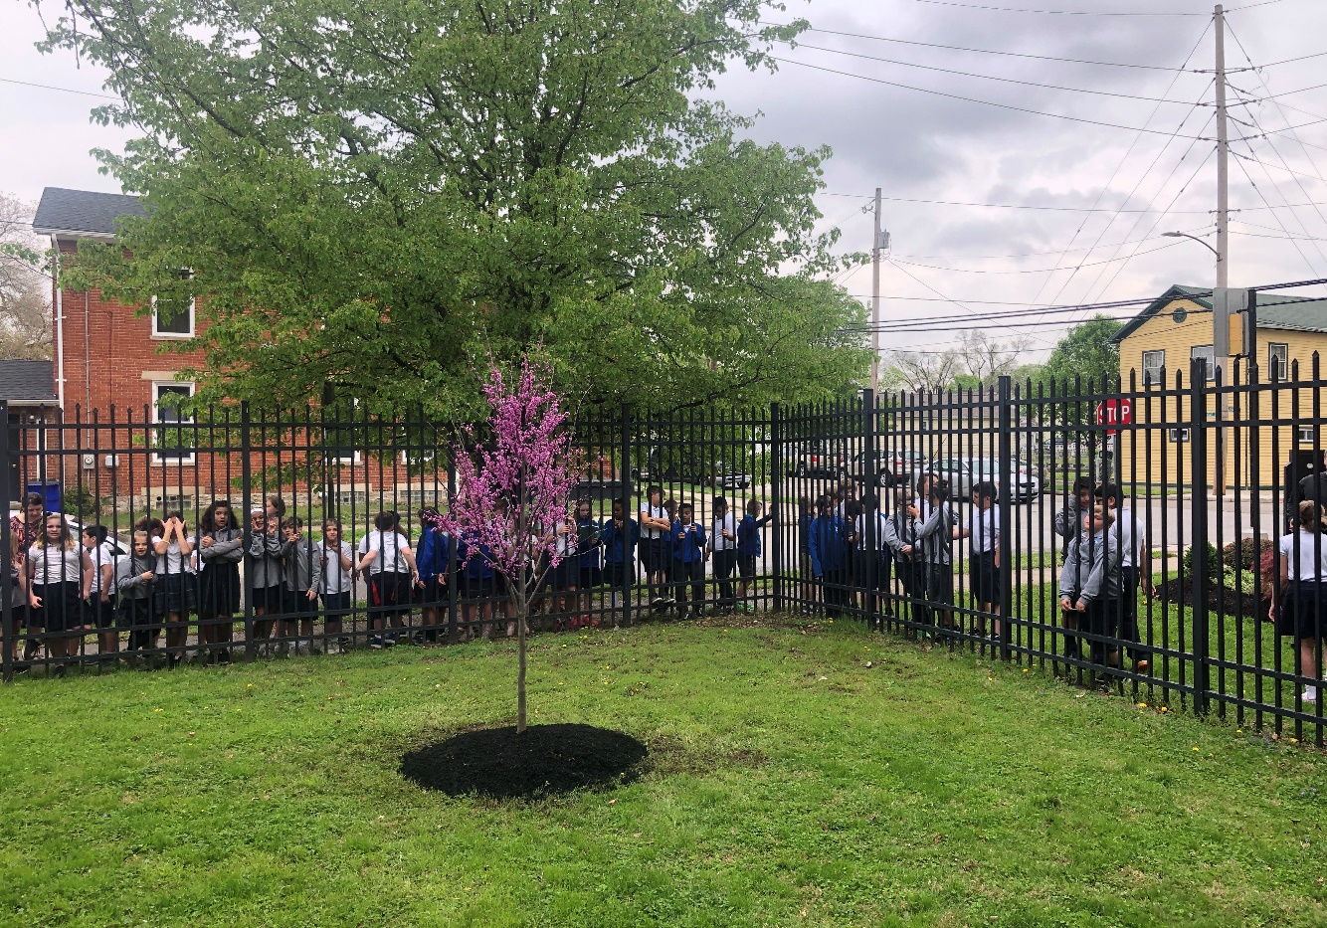

May 2020

About Spring Tree Plantings

Every spring typically in May, the City of Hamilton plants around 100 new trees in City parks and the public right-of-ways (the green space between the sidewalk and curb). The planting locations are chosen randomly and a tree is hand selected for each location to insure that the tree will have the adequate space to grow and it will not interfere with the surrounding infrastructure (i.e. buildings, sidewalks, utilities). Before the planting begins, letters will be sent out to each home where a tree will be planted to notify the owner. Then, underground utilities will be marked with paint as well as a white dot as to where the new tree will be planted. Once a new tree is planted, a tree gator bag will be placed around the base of the tree. For the next two years, the City will fill these bags with water because newly planted trees require more frequent watering than older, well-established trees. If you have any questions about new tree plantings, you can contact the City’s Municipal Arborist, Dave Bienemann at (513) 785-7556 or dave.bienemann@hamilton-oh.gov.

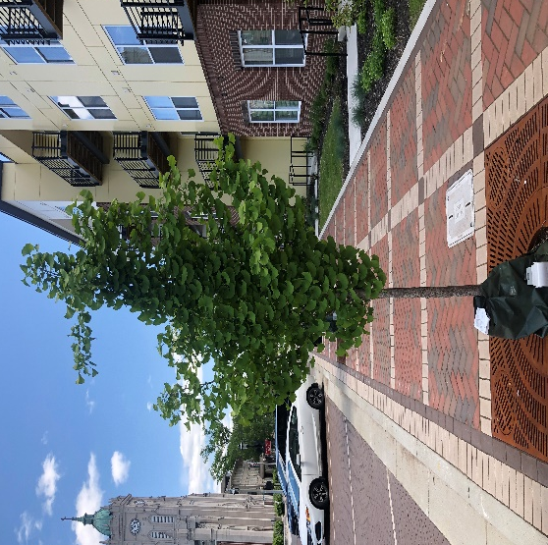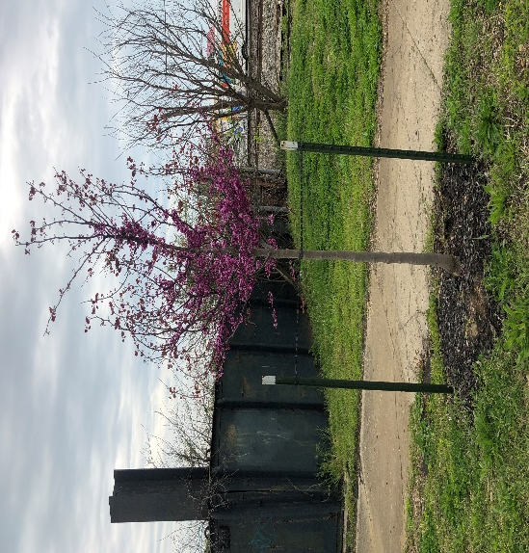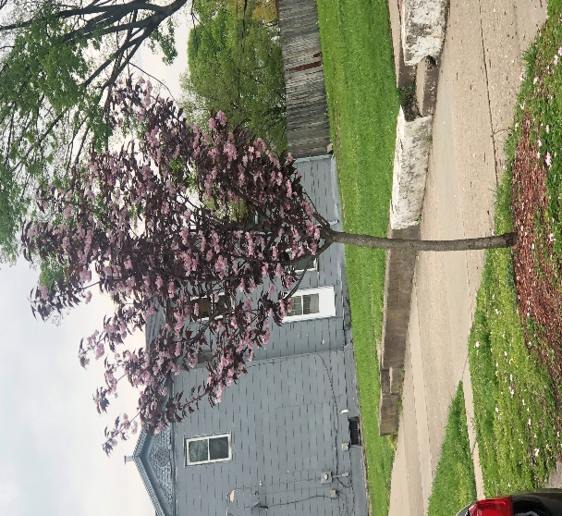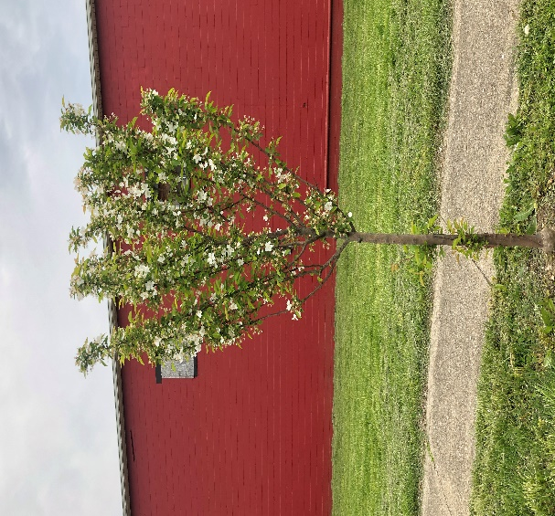

June 2020

Spotted Lanternfly

The Spotted Lanternfly (Lycorma delicatula) is a plant hopper native to China, India, and Vietnam. It was first detected in Pennsylvania in September 2014. Here, the Spotted Lanternfly is an invasive species which means it is a non-native that has the ability to spread to a point in which it can harm the environment, the economy, or even human health. It feeds on a wide range of fruit, ornamental and woody trees, with tree-of-heaven being one of the preferred hosts. With this being said, this insect has the potential to greatly impact agricultural crops such as grapes, hops, and hardwoods. For more information and how to look for and report the spotted lanternfly, visit https://www.invasivespeciesinfo.gov/profile/spotted-lanternfly

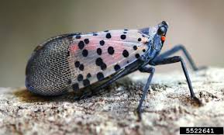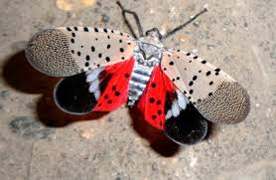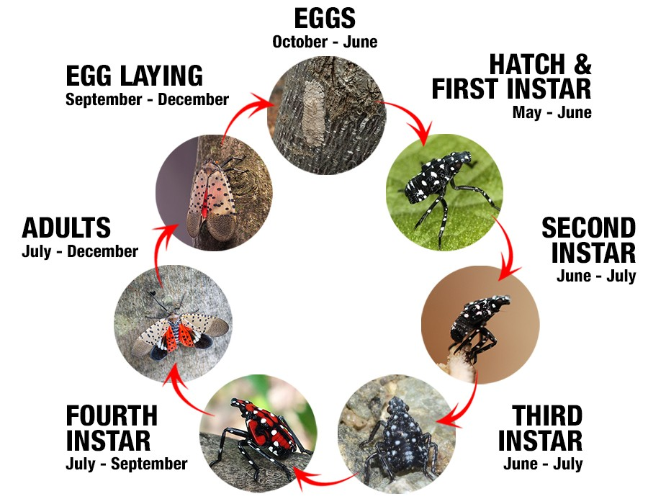

July 2020

Remarkable Tree Calendar

In January of 2021, we plan to release a remarkable tree calendar to the public via social media. Throughout the rest of this year we are asking for people to submit nominations (pictures and location) of remarkable trees around Hamilton. Some examples could be large, healthy trees that standout and provide a large shade canopy or those with notable fall colors or unique features. These submissions will be due the end of the 2020 year. We will then select 12 trees, which will be featured in the 2021 remarkable trees of Hamilton calendar. The calendar will include a selected tree picture for each month, the tree’s common name, scientific name, location, the person who took the photo, and a description about the tree. Please send your nominations to dave.bienemann@hamilton-oh.gov.

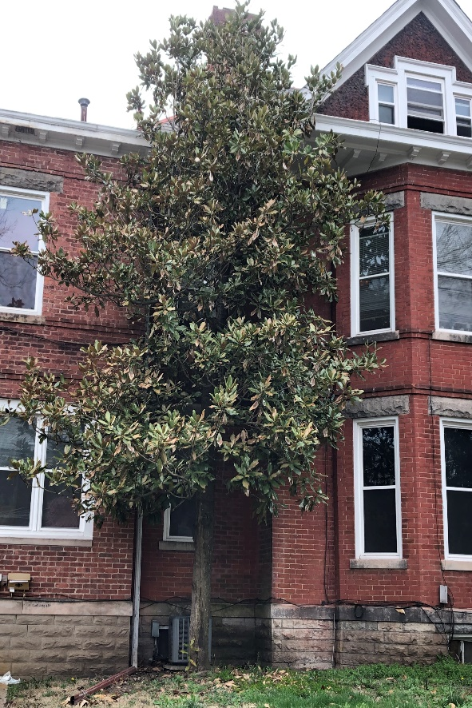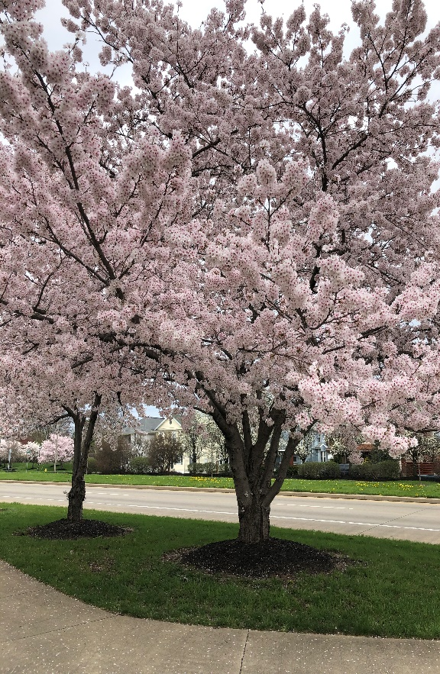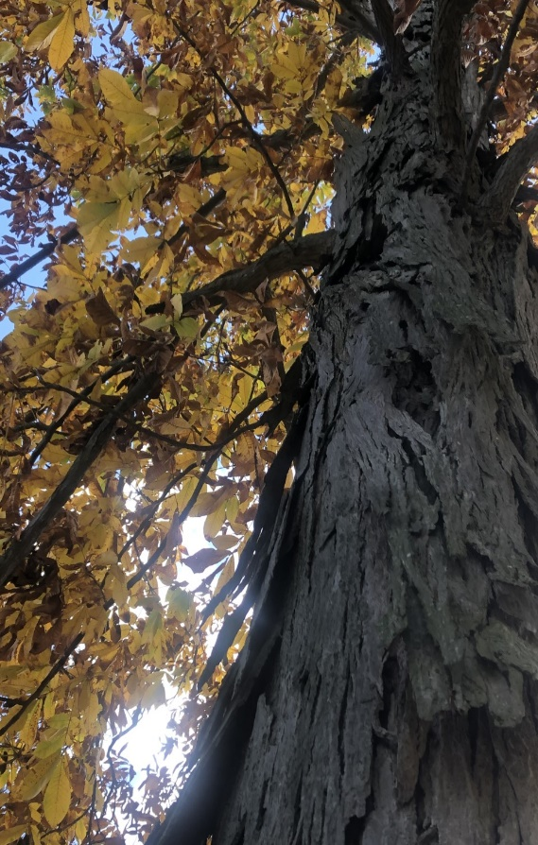

August 2020

The Benefits of Urban Trees

Trees provide many amazing benefits for us that are often overlooked. They help to improve the environment we live in by providing economic benefits and increasing the quality of life. In the City of Hamilton we have over 13,600 park and urban trees in the right-of-ways.
