

Sales and Use Tax
Blanket Exemption Certificate

The purchaser hereby claims exception or exemption on all purchases of tangible personal property and selected services made under this certificate from:

(Vendor’s name)

and certifies that the claim is based upon the purchaser’s proposed use of the items or services, the activity of the purchase, or both, as shown hereon:
The City of Hamilton is claiming exemption because it is a political subdivision of the State of Ohio.
This certificate shall continue in force until revoked and shall be considered a part of each order given to the above named vendor unless the order specifies otherwise.

FEDERAL TAX EXEMPT NUMBER: 31-6000142
STATE TAX EXEMPT NUMBER: 51-159951-6

Purchaser must state a valid reason for claiming exception or exemption.

City of Hamilton Purchaser’s name
345 High Street
Street address

Hamilton, OH 45011 City, state, ZIP code
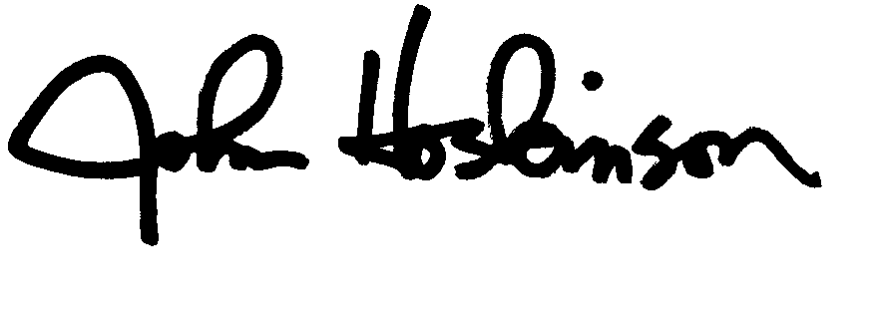

Purchasing Agent Signature Title

3/19/2014 Date Signed

Vendor’s license number, if any

Vendors of motor vehicles, titled watercraft and titled outboard motors may use this certificate to purchase these items under the “resale” exception. Otherwise, purchaser must comply with either rule 5703-9-10 or 5703-9-25 of the Administrative Code. This certificate cannot be used by construction contractors to purchase material for incorporation into real property under an exempt construction contract. Construction contractors must comply with rule 5703-9-14 of the Administrative Code

